Products database

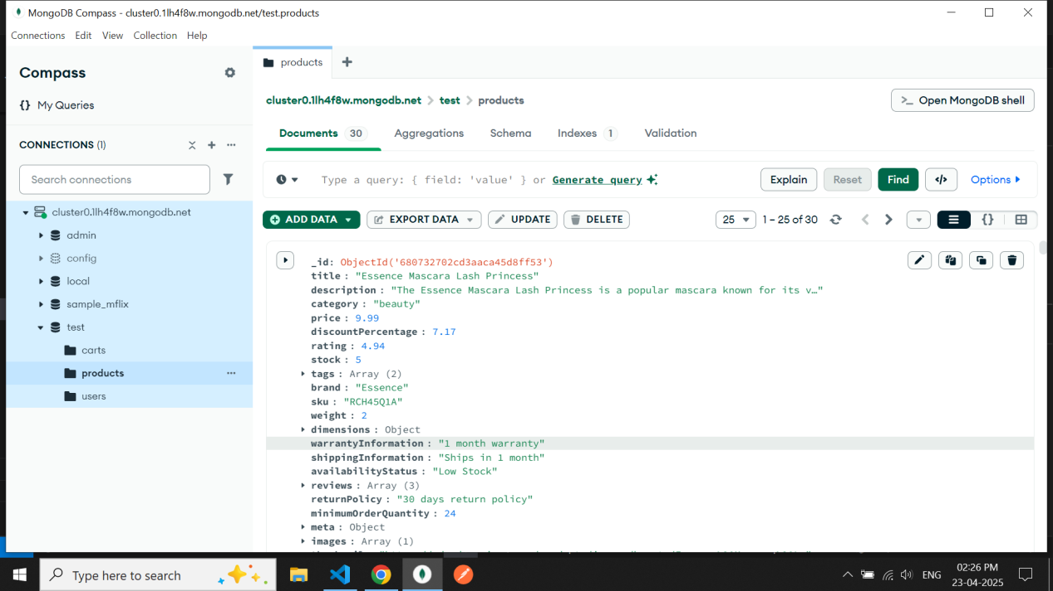

Api route

Get /products fetch all the products if we don’t pass the id of product

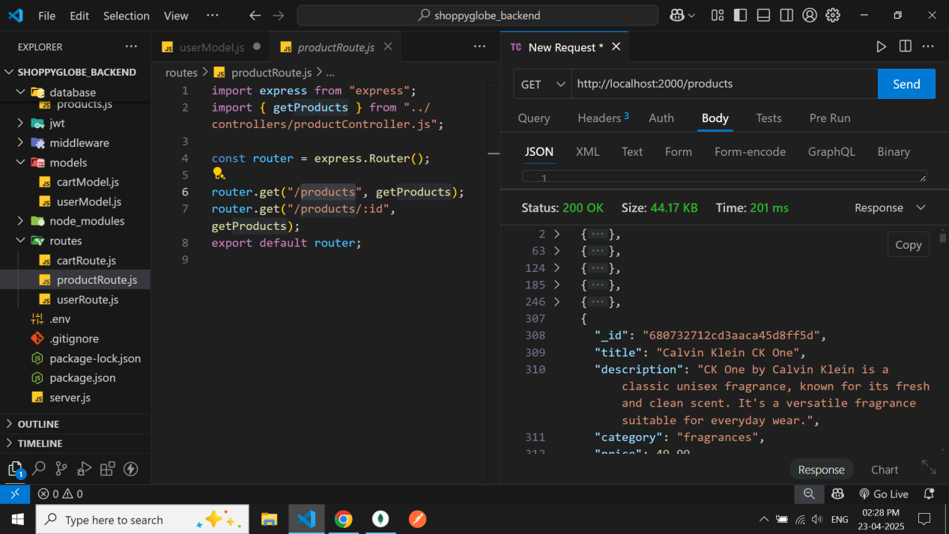

Api route

Get /products/:id fetch the specific product from the databaseby using dynamic id

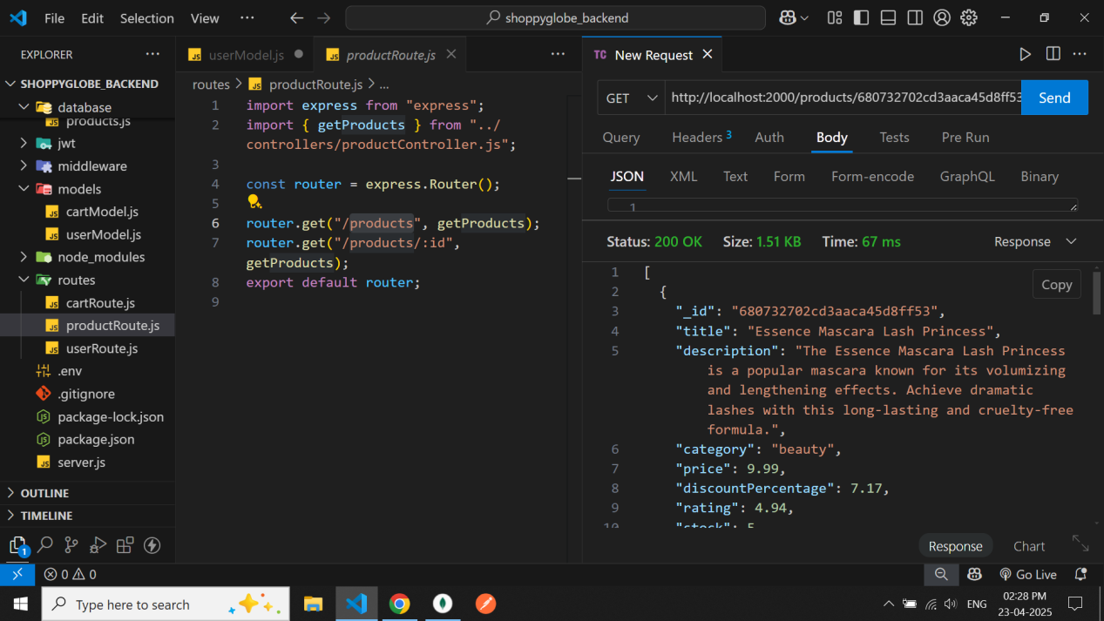

Database initially for users

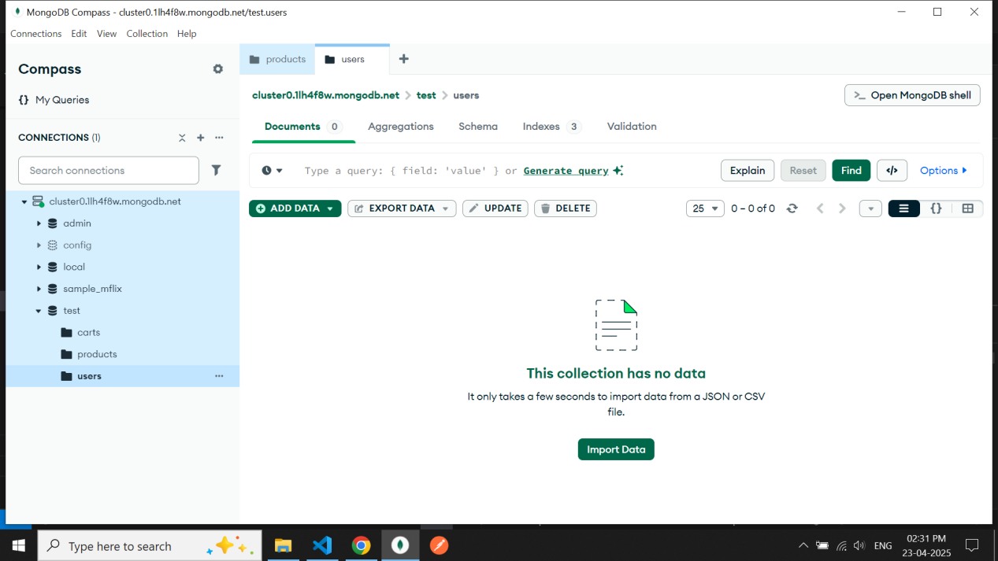

Api route

Post /register to register the user we need to pass username password email mobile no to request body

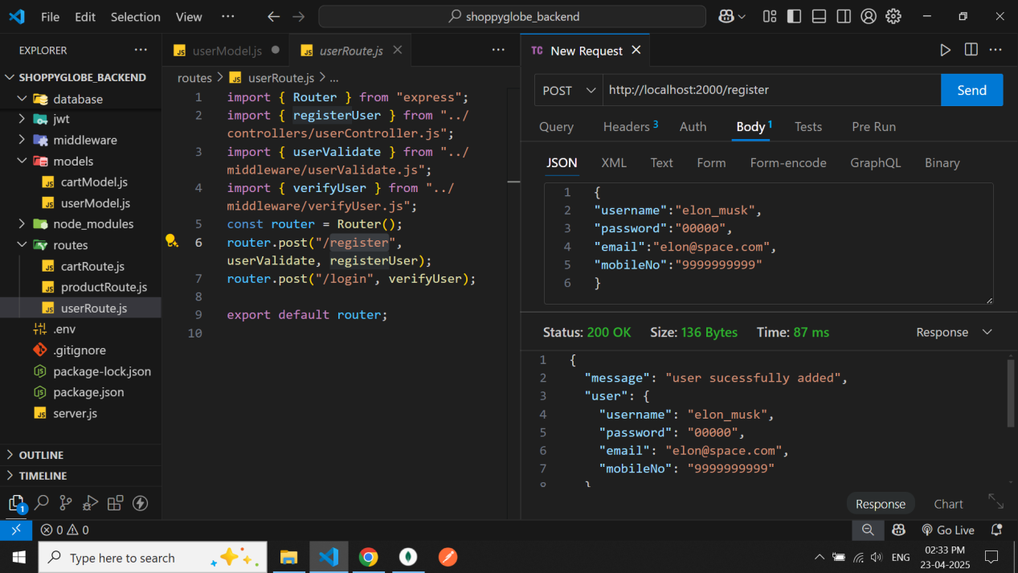

Databse after user added

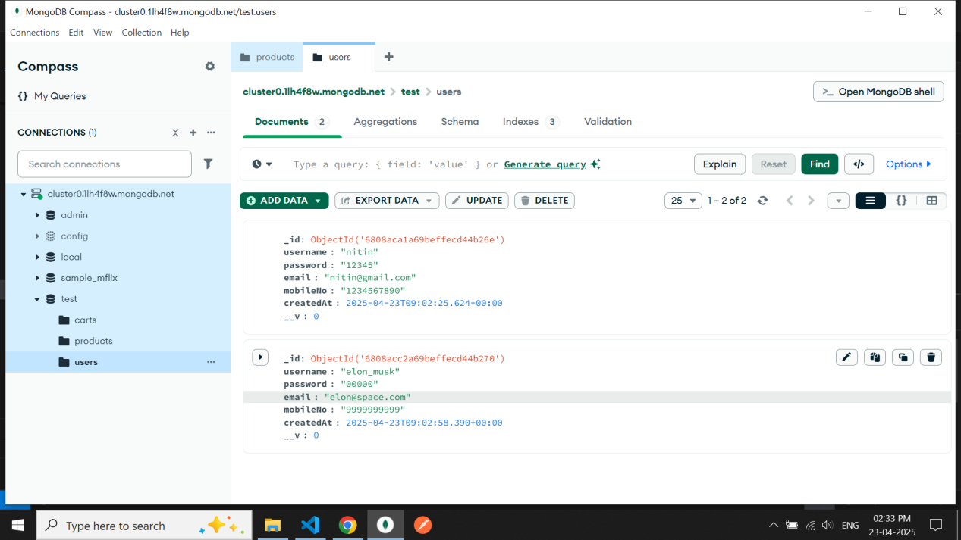

Api route

Post /login login the user we need to pass username and passsword to request body

It will return a jwt token to us for cart protected routes

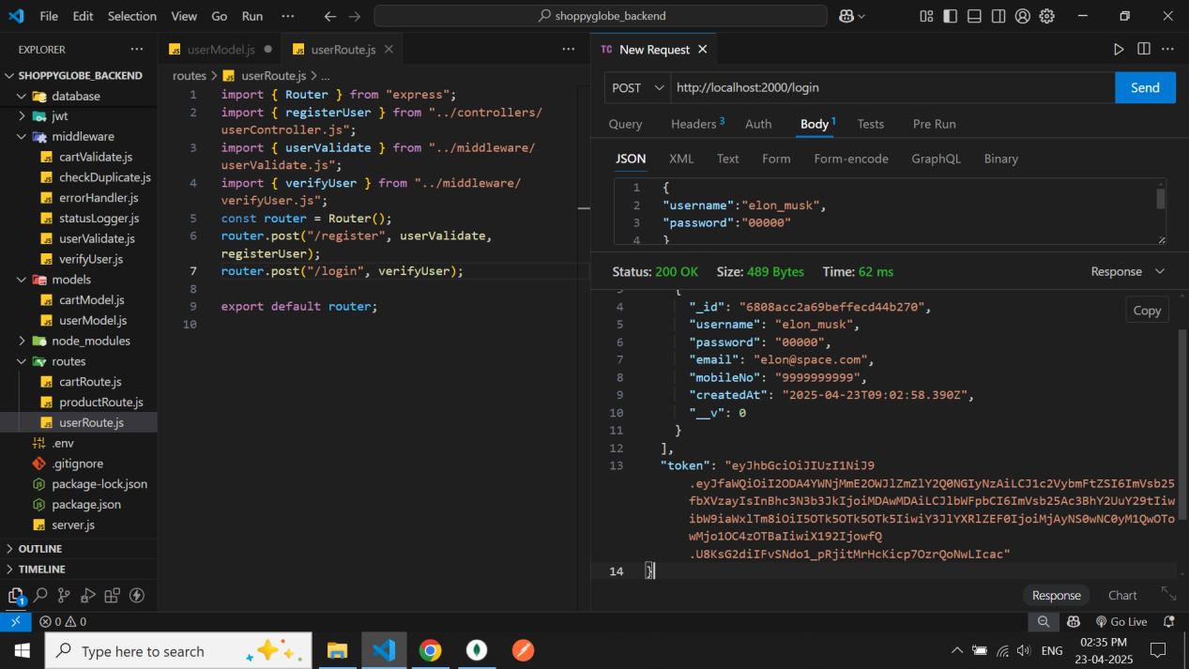

Database of cart initially

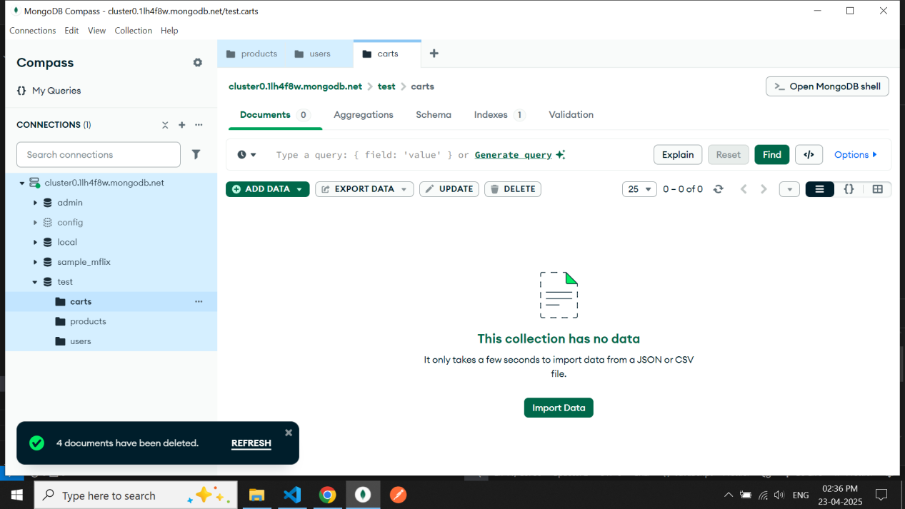

Api route

Post /cart

to insert cart item to cart database we need to pass product id and quantity to request body and a

jwt token to headers to verify the user only verified user can update add and delete the cart database

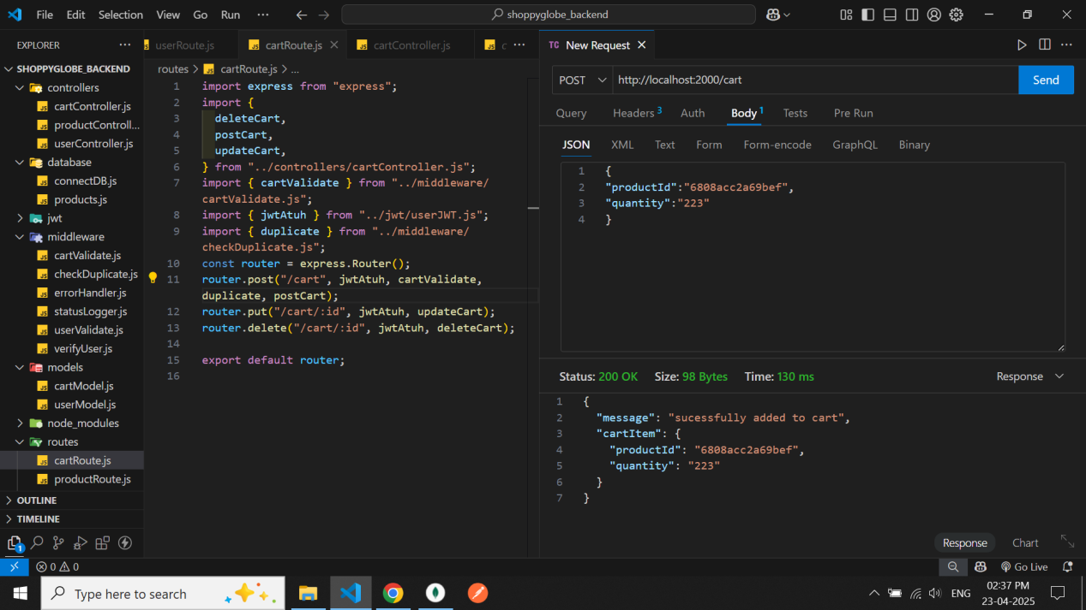

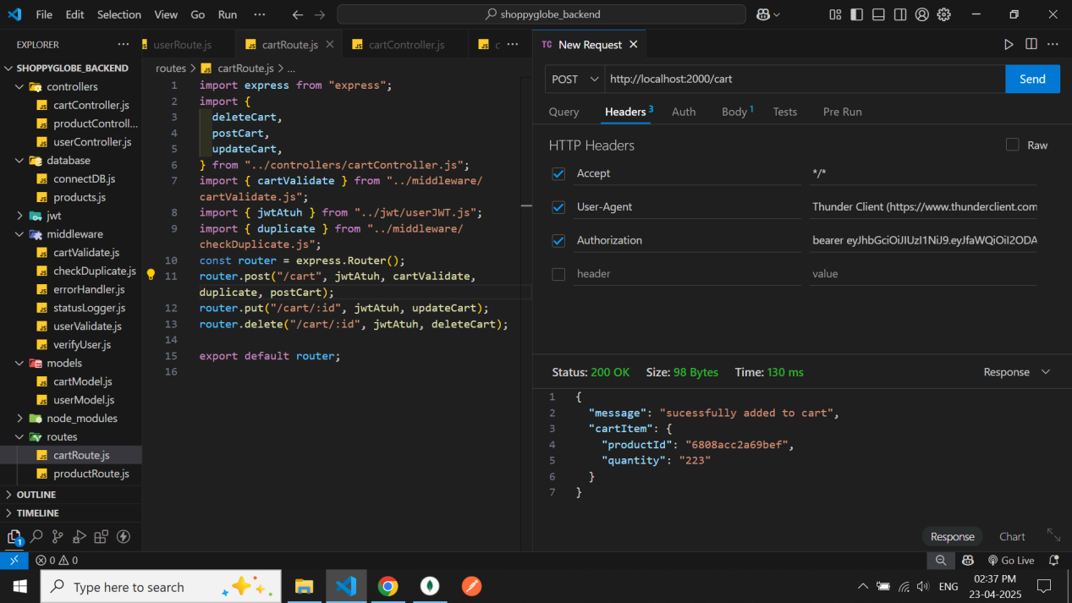

Middleware check that we cant add duplicate items to cart

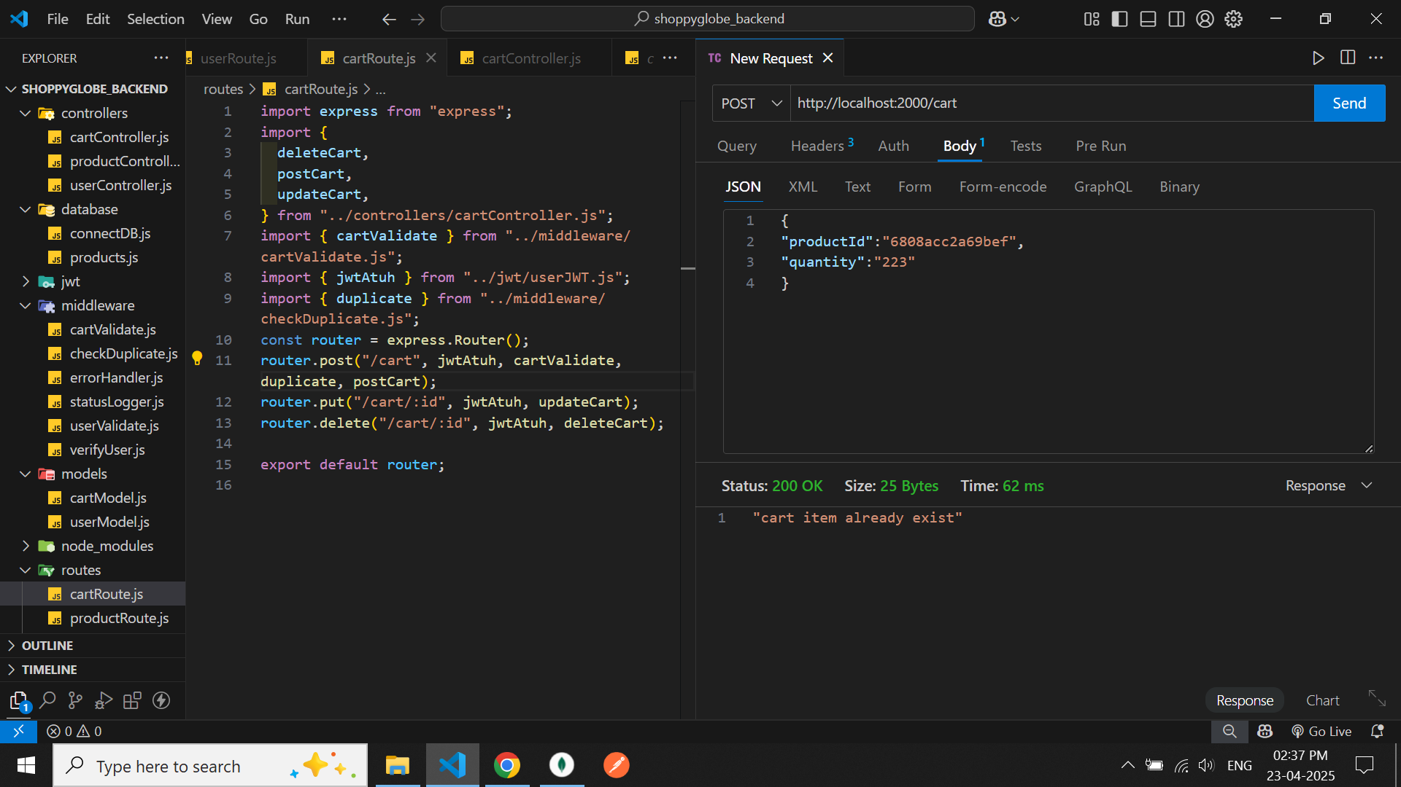

**Unothorized** user cant update add and delete the cart database

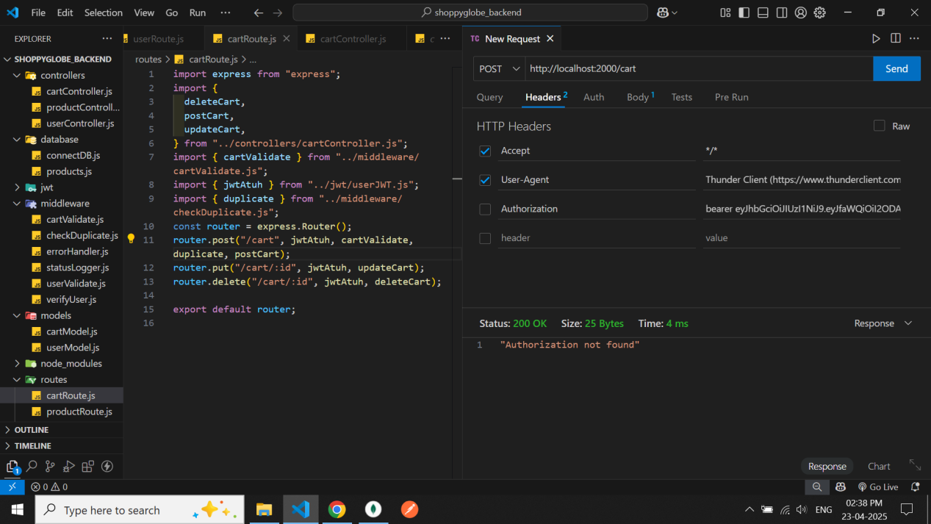

Cart database after cart item added to cart

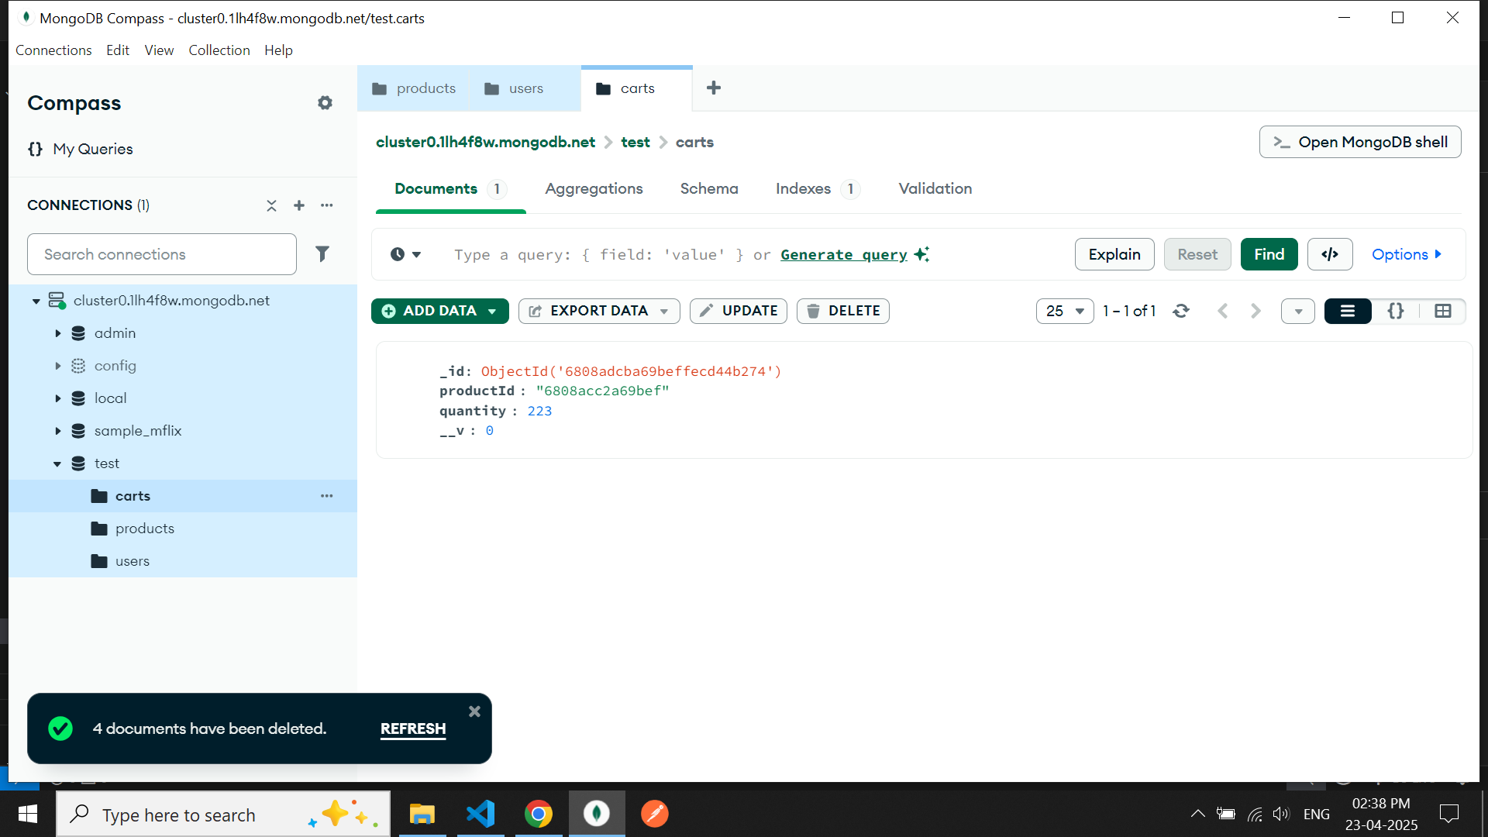

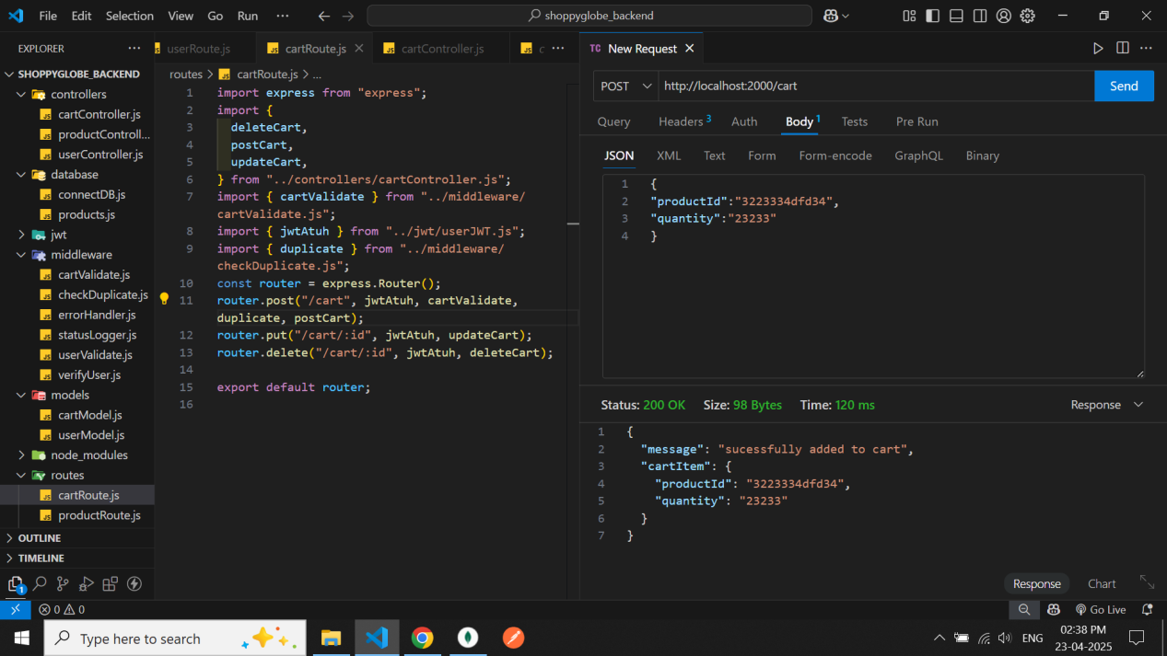

Before update the cart using put method

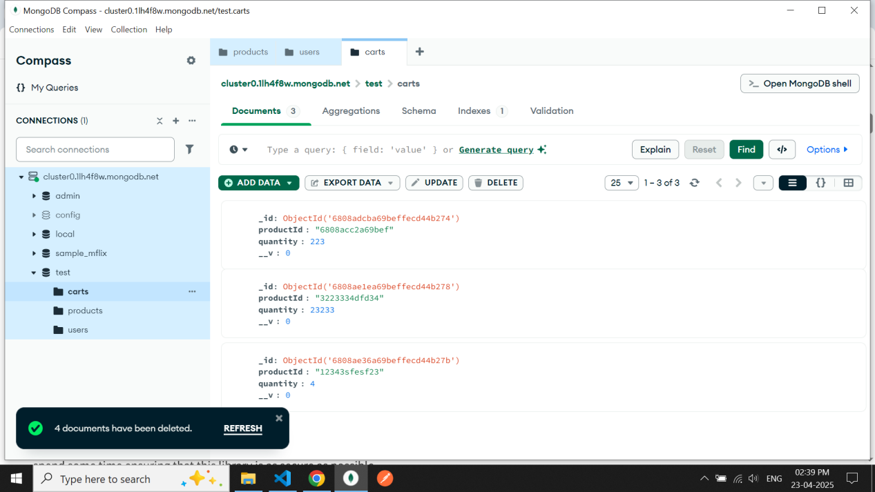

Api route

Put /cart/:id

To update the cart item we need to pass the quantity in req.body,jwt token in headers and a product id to specifically target that product

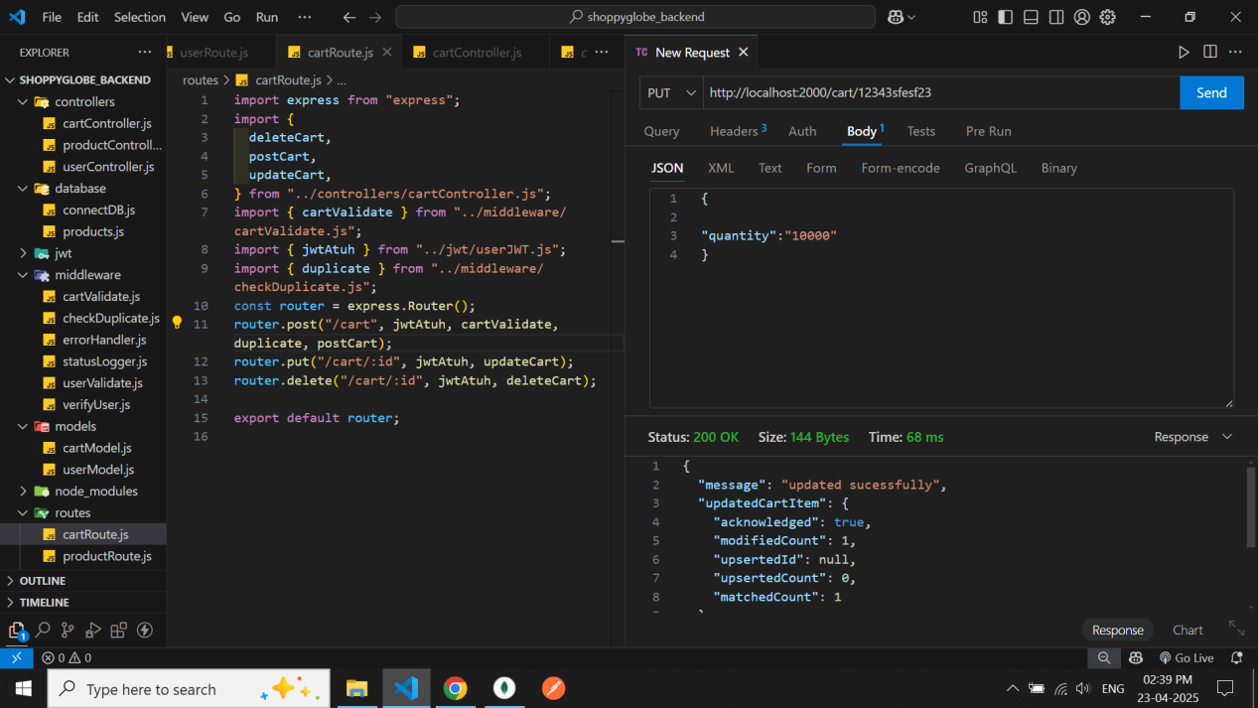

After updating the cart item

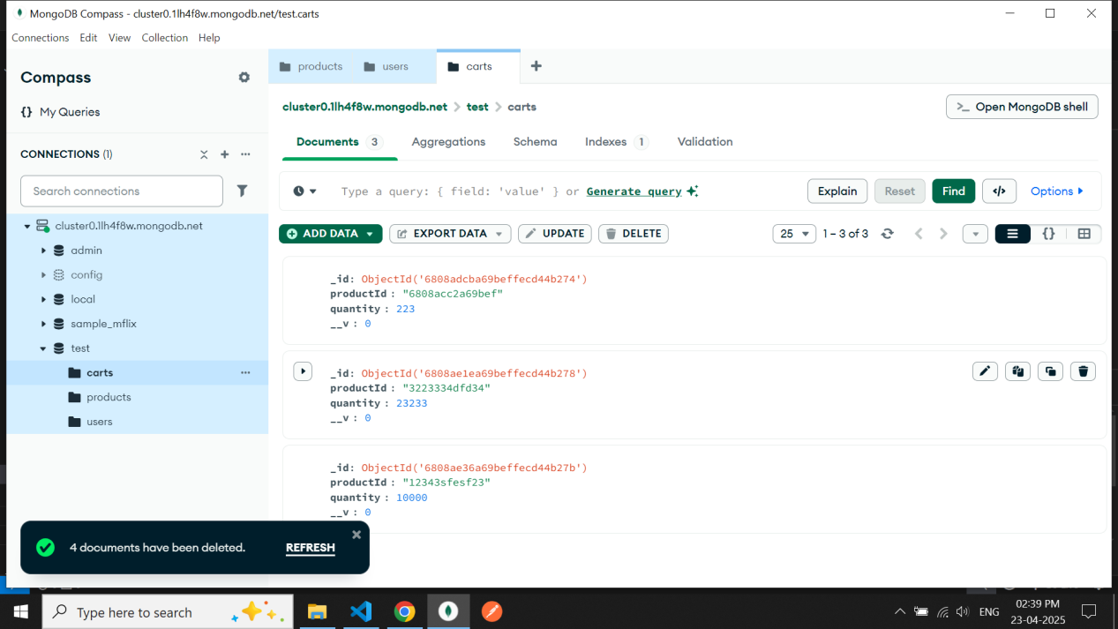

Api route

Delete /cart/:id

We need to pass id and jwt token to delete the specific cart item from database

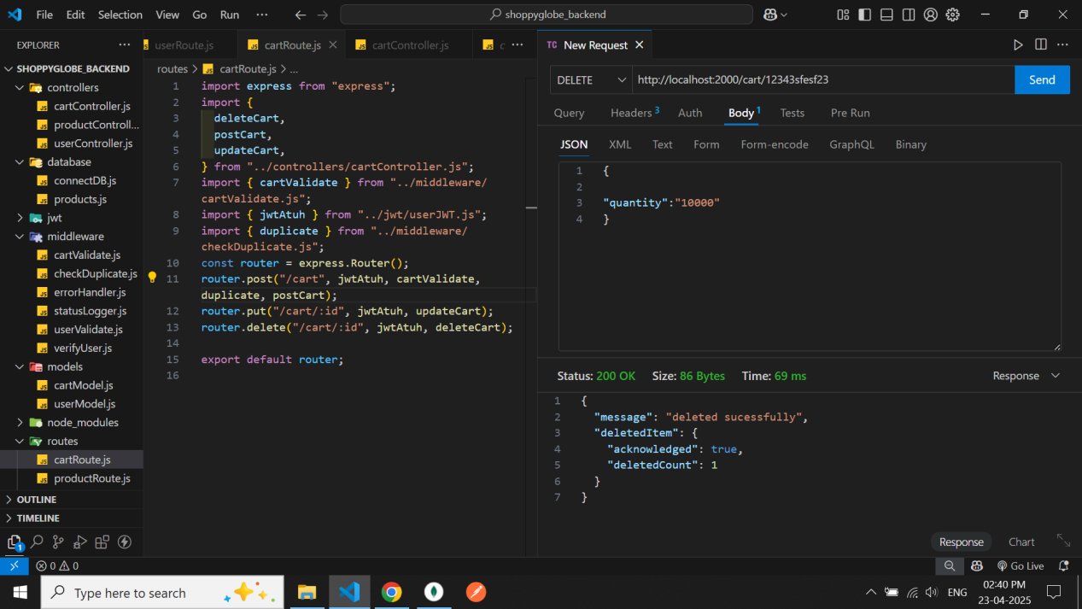

After deleting the specific cart item from database

